Goal of project:

To implement a website with the following requirements

1. Adaptive Home page
2. Signup/login section

a.1. One or more of the following Google/linkedin/github sign in implementation

a.2. Have a Slider Authentication form like the following **P.1**

1. background image containing picture collage of completed projects

b.1. This is a easy one with setting the home page as the background image

1. User home page (refer to wireframe)
2. The center page will have a grid or list display of projects

a.1. The projects should be displayed like this when in grid form **P.2**

a.2. When in list form it should be displayed like this **P.3**

b.

1. User setting page

Discuss user setting

1. Main “canvas” page (this is where the designs are made)

Discuss a dom illustrator where you can paste your html and it prints out a diagram for your dom

-add images

-draw on the canvas

-upload user profile pic

Trimmed down goal

1. Types of graphs you’ll be able to make:  
   **Software Engineering**:
   * **Uml diagram:** a way to visually represent the architecture, design, and implementation of complex software systems.
2. **Cybersecurity**:
   * **Network Topology Diagrams**: Used to depict the structure of a network.
3. **Web Development**:
   * **Wireframes**: Simple sketches or diagrams to plan the layout and structure of a web page.
4. **Computer Science**: cant decide
   * **Tree Diagrams**: Illustrate data structures like binary trees or decision trees.

References:

P.1



P.2

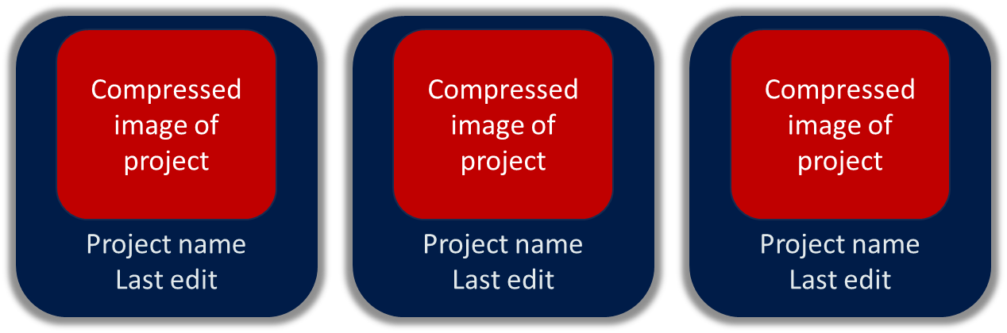

P.3

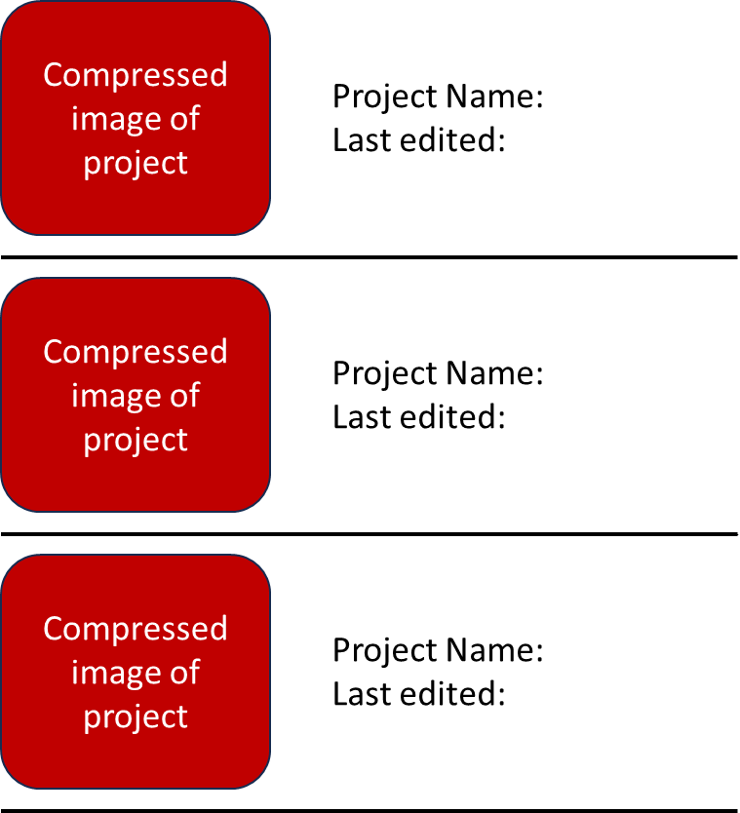

P.4

Useful links:

L.1. <https://www.w3schools.com/css/css3_borders.asp>